ECE59500 Final Project IN PROGRESS
December 10, 2025

Tackling the Traveling Salesman Problem with Reinforcement Learning and Genetic Algorithms
By: Connor Russell Plaks, Michael Yudanin, Ari Vauhkonen

INTRODUCTION
This report summarizes our final project for ECE59500. We tackle the traveling salesman problem (TSP) by applying a combination of reinforcement learning and genetic algorithms. This approach was first presented in the article "Combining reinforcement learning algorithm and genetic algorithm to solve the traveling salesman problem" by Ruan et. al [1]. As part of our project we implement the algorithms in order to assess how well the approach presented in the paper works in practice. Background, motivation, methodology and the results are presented and discussed. In addition, the report provides conclusions with suggestions for future work.

MOTIVATION AND BACKGROUND
The Traveling Salesman Problem (TSP) presents a classic challenge in combinatorial optimization, with wide-ranging applications where finding the shortest or most efficient route is critical. The challenge is to find the optimum route for visiting each city exactly once and eventually returning to the starting city. Besides the obvious use cases involving travel logistics such as optimizing airline travel or package delivery routes, TSP is used in several other fields, including but not limited to mathematics, scheduling, genetics, computer science and circuit design [2], hence yielding itself as a popular research topic for finding increasingly more efficient ways to tackle the problem.
Traditionally methods such as heuristic algorithms, simulated annealing and dynamic programming have been used for solving TSP [3,4]. They often work well for specialized and contained problems but when they become large more efficient algorithms are needed. Reinforcement learning and genetic algorithms have been showing superior results over the traditional methods in recent years [5,6]. The novel idea of the paper we based our project upon is to combine the two algorithms. First reinforcement learning is utilized for strategy and arriving at effective alternative solutions for paths and then a selected genetic algorithm refines them through global search towards an optimal solution [1].
METHODOLOGY
At the core of our work is to develop and implement hybrid algorithms that combine reinforcement learning with genetic algorithms to solve the Traveling Salesman Problem (TSP).
For reinforcement learning, double Q -learning algorithm was selected as was in the paper that we based our work upon. Traditional Q-learning tends to often yield in overestimation, while double Q -learning approach provides a more stable solution by keeping two independent Q-value functions [7].
The Q-learning algorithm operates as:
- Action selection: Use an 𝜀-greedy policy based on the current state s and Q-value functions to select the next city.
- Action execution: Move to the next city based on the elected action.
- Reward calculation: Calculate the immediate reward based on the distance between cities.
- Update Q-value functions: Use the update rules of double Q-learning to update the estimation of both Q-value functions.
Then the optimal action is determined based on the average of the two Q-value functions. Once reinforcement learning has yielded in multiple optimum paths , then a selected genetic algorithm refines them through global search towards an optimal solution as follows:
- Selection: The selection operation is responsible for choosing a certain number of individuals from the current population to serve as parents for the evolution process. The roulette wheel selection method is employed, where the probability of selecting an individual is directly proportional to its fitness.
- Crossover: The crossover operation is responsible for generating new individuals by combining two parents. Experimental choice of single-point crossover method, where a random crossover point is selected in both parents, and the portion of the chromosome after the crossover point is exchanged between the two parents. This method preserves information from the parents while introducing new genetic variation
- Mutation: The mutation operation introduces randomness to increase the diversity of the search. The insertion mutation method is utilized in the approach, where two positions in an individual’s chromosome are randomly selected,and the sequence of cities between these two positions is reversed. This mutation method retains existing city visitation information while introducing some randomness.

The flow chart for the approach is summarized in Figure 1.
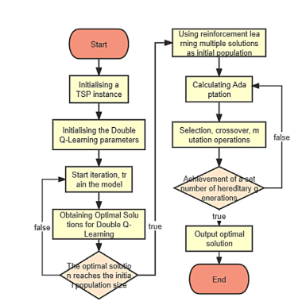

Figure1. Flow Chart of the algorithm

We implement and evaluate the performance of these approaches on benchmark datasets, analyze their effectiveness, and identify the best-performing algorithm(s) through comparative results.

SETUP
Dataset, TSP instances, n:o optimal routes, hyper parameters, libraries, reference to code ..

OUTCOMES AND DISCUSSION
Results , discussion ….
LITERATURE REVIEW
Literature review….relevant how do our work fit into into existing works
CONCLUSIONS AND FUTURE WORK
Conclusions and future work…. if someone wants to pick up your work what direction would be interesting

REFERENCES

[1] Ruan Y., et al: Combining reinforcement learning algorithm and genetic
algorithm to solve the traveling salesman problem. The Journal of Engineering ...
[2] Le, A.V., et al.: Coverage path planning using reinforcement learning-based
TSP for hTetran–a polyabolo-inspired self-reconfigurable tiling robot.
Sensors 21(8), 2577 (2021)
[3] Gharib, A., Jamal, B., Mohsine, C.: A performance comparison of PSO and
GA applied to TSP. Int. J. Comput. Appl. 130(15), 34–39 (2015)
[4] Halim, A.H., Ismail, I.: Combinatorial optimization: comparison of heuris-
tic algorithms in travelling salesman problem. Arch. Comput. Methods
Eng. 26, 367–380 (2019)
[5] Zhang, Z., et al.: Solving dynamic traveling salesman problems with deep
reinforcement learning. IEEE Trans. Neural Networks Learn. Syst. 34(4),
2119–2132 (2021)
[6] George, T., Amudha, T.: Genetic algorithm based multi-objective opti-
mization framework to solve traveling salesman problem. In: Proceedings
of the Advances in Computing and Intelligent Systems: ICACM 2019, pp.
141–151. Springer, Singapore (2020)
[7] Van Hasselt, H., Guez, A., Silver, D.: Deep reinforcement learning with
double Q-learning. In: Proceedings of the AAAI Conference on Artificial
Intelligence, pp. 2094–2100. ACM, New York (2016)

APPENDIX

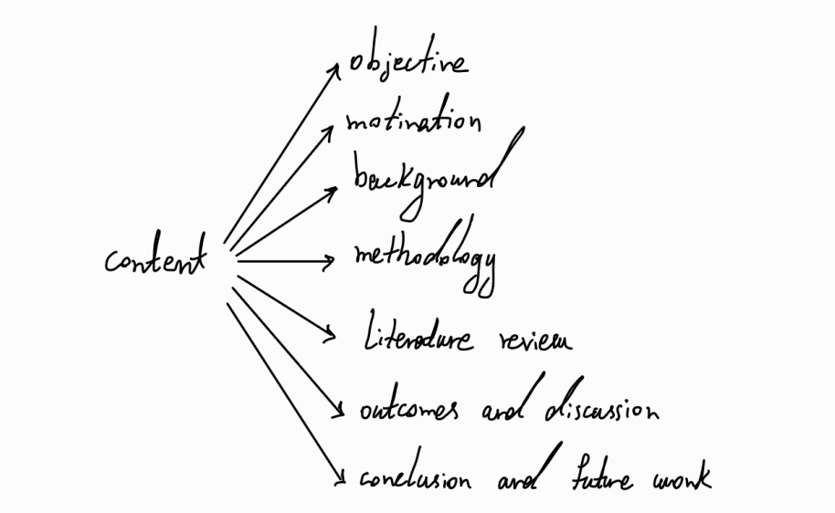
Up to 8 pages

